Cyber Attack Detection Using Machine Learning Algorithms
Project submitted to the
SRM University – AP, Andhra Pradesh
for the partial fulfillment of the requirements to award the degree of

Bachelor of Technology
In
Computer Science and Engineering
School of Engineering and Sciences

Submitted by
Nazeer Mastan Basha(AP21110011037)
Charan Reddy(AP21110010988)
Rehan(AP21110010259)
Abhiram(AP21110011017)


Under the Guidance of
Dr. Tapas Kumar Mishra
SRM University–AP
Neerukonda, Mangalagiri, Guntur
Andhra Pradesh – 522 240
Nov, 2023

Certificate

Date: 1-Dec-23

This is to certify that the work present in this Project entitled “Cyber Attack Detection Using Machine Learning Algorithms” has been carried out by [Nazeer Mastan Basha, Sai Charan Reddy, Venkata Sai Rehan, Abhiram Maddukuri] under my/our supervision. The work is genuine, original, and suitable for submission to the SRM University – AP for the award of Bachelor of Technology/Master of Technology in School of Engineering and Sciences.

Supervisor

(Signature)
Dr.Tapas Kumar Mishra
Assistant professor
Department of CSE
SRM UNIVERSITY AP.

Table of Contents

Abstract iii
Abbreviations iv
List of Tables v
1. Introduction 1
Perfomance evalution matrices……………………….………………………………..3
2. Data Set Discription………………………..……………………………….……………7
3. Simulation Results……………………………………………………………………….8
References 10

Abstract

Nowadays we are using the internet very frequently, Mostly all our work can be done on the internet. We are extending the utilization of the internet services on a very huge scale in our day to day life. Due to a rapid enhancement in technology and internet services the likelihood. Cyberattacks are going to be higher as well and the types of attacks may intensify and a new variety of attacks may make its way into the systems. It is very important to counter cyber attacks. This work aims to perform an analysis on the machine learning algorithms to detect the cybersecurity attacks on datasets and also represents a comparison between the existing models of machine learning algorithms.

Abbreviations

ML Machine Learning
SVM Support Vector Machine
KNN K-Nearest Neighbors

List of Tables

Introduction

A cyberattack is referred to as any type of attack on a computer system, computer network, etc. The attacker may be a person or group of individuals who are aiming to steal the information that is securely stored in a system without any type of authorization which is undoubtedly used to cause mishaps. Cyber Attack is used for stealing, destroying or altering existing data, this types of attacks are mainly divided into two types:

1.1 Active Attack: The attack can be active if and only if it aims to alter or cause an effect on the resources. The active is generally more dangerous than the passive attack, due to active attacks the system in which resources are stored always gets damaged. It is easy to detect the active attack because the scale at which it works is big therefore the victim is informed about the attack that had happened before, which in turn is easy to prevent from this happening. There are different types of active attacks. Distributed Denial Of Services(DDOS), Masquerade attack, Session hijacking, Replay attack etc…

1.2 Passive Attack: A passive attack is a type of attack where the attacker tries to gain information by indirect contact with the system. In a passive attack, the attacker generally tries to observe the information and make a copy of it to cause more mishaps. Due to its nature of not altering the data like an active attack, a passive attack is very difficult to detect for a long time which can cause significant loss of confidential data in an organization. Unfortunately, unlike the active attack, the victims don't get informed about the attack. There are different types of passive attacks. Release of message contents, Traffic analysis, Network mapping, Sniffing, etc…

2 Machine Learning in Cyber Security

By offering cutting-edge tools and methods to identify and counteract cyber threats, machine learning plays a critical role in improving cybersecurity. Algorithms for machine learning can recognise trends and abnormalities in large datasets that can point to malicious activity. As a result, threats can be detected more quickly and accurately, enabling cybersecurity systems to react and adjust instantly. Additionally, machine learning helps create predictive models that cybersecurity experts may use to foresee possible attacks and weaknesses. It also makes it easier for repetitive processes to be automated, freeing up human resources to work on more intricate cybersecurity jobs. Machine learning continues to be a vital ally in strengthening defense and staying ahead of new threats as cyber threats continue to grow.
Supervised machine learning algorithms play a crucial role in cybersecurity by leveraging labeled datasets to train models for threat detection and classification. These algorithms learn from historical data, identifying patterns associated with known cyber threats. Once trained, they can analyze network traffic, detect anomalies, and classify activities as either normal or malicious. This proactive approach enables organizations to swiftly respond to potential security breaches, enhancing the overall resilience of cybersecurity systems. Supervised algorithms are particularly effective in identifying known attack patterns, aiding in the timely identification and mitigation of security risks.

2.PERFORMANCE EVALUTION MATRICES
We have implemented few algorithms in ML and we came to know that how they are detecting cyberattack by using performance evaluation parameters they are

1. Accuracy: The measure of the ratio correctly predicted instances to the total instances in the dataset.
2. Precision: It focuses on the proportion of true positive predictions out of all positive predictions mainly. It is important when false positives are costly.
3. Recall: It is the ratio of true positives to the actual positive instances.
It is important when false negatives are costly.
4. F1 Score: It is harmonic mean of precision and recall and it provides balance between two metrics.

2.1 Machine learning algorithms
Machine Learning (ML) algorithms are computational models and statistical techniques that enable computers to perform a task without being explicitly programmed for that task. In other words, these algorithms allow machines to learn patterns and make decisions based on data. The primary goal of using ML algorithms is to develop models that can generalize patterns from data and make predictions or decisions on new, unseen data.
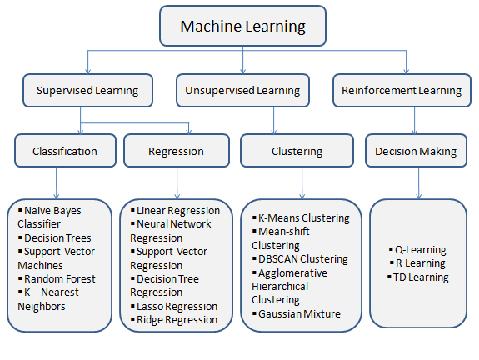
2.1.1 Machine learning Algorithms:
In this project we used only few algorithms because these algorithms are commonly used in cybersecurity for detecting and preventing cyber attacks.
1. Decision Tree:

A decision tree is a hierarchical diagram resembling a tree, in which every inner node signifies an evaluation of an attribute, each pathway represents a result of that evaluation, and each terminal node contains a classification label. Decision Tree is used for classification and regression also using the data in the dataset by true or false as answers to certain questions.

Root Node: The Decision Tree Starts from the root node. It plays a major role in forming the decision tree. It represents the entire dataset and divides it into homogenous sets of two or more than two.
Internal Node : An internal node in a decision tree is like a decision point where a specific attribute is tested. It's a part of the tree where the tree branches out based on the outcome of this test.

Branch : A branch in a decision tree is like a path or route that the tree can take at an internal node. It represents one of the possible outcomes or decisions based on the attribute test at that node.

Leaf Node : A leaf node in a decision tree is like a final destination or endpoint. It represents the ultimate decision or classification made by the tree. It typically holds a class label or outcome that concludes the decision-making process.

2.1.2 Random Forest:

Random forest is a machine learning model designed by Leo Breiman and Adele Culter, which merges the output of multiple decision trees to reach a final output.
Tree based models are the building blocks of the random forest algorithm. This model involves recursive partitioning of the given dataset into n-decision trees. The predictions obtained from each decision tree via leaf node is merged together to produce a result
Random Forest = Recursive partition of DATASET into decision trees + Prediction of each Decision tree + Merging all predictions into one result

2.1.3 K-Nearest Neighbors (KNN):
K-Nearest Neighbours is one of the most basic yet essential classification algorithms in Machine Learning.
It belongs to the supervised learning domain and is used in applications like pattern recognition, data mining, and intrusion detection.
Choosing K: You select an appropriate value for K, which determines the number of nearest neighbours to consider when making predictions. This choice can significantly impact the model's performance and may require experimentation.
Distance Metric: You choose a suitable distance metric, such as Euclidean distance, to measure the similarity between data points in the feature space.
Model Training: You train the KNN model using the training dataset. The model learns to identify patterns in the network traffic data.
Intrusion Detection: For each entry in the testing set, you apply the trained KNN model. Here's how it works:
The KNN algorithm calculates the distance between the test data point (an entry in the network logs) and its K-nearest neighbours from the training data. If the majority of the K-nearest neighbours are labelled as "intrusions," the KNN model classifies the test data point as a potential intrusion. Otherwise, it classifies it as normal network traffic.
Alert Generation: When the KNN model classifies a network activity as a potential intrusion, it triggers an alert to notify the cybersecurity team. The team can then investigate the alert and take appropriate action to mitigate the threat, such as blocking the malicious IP address or applying security patches.
Feedback Loop: Over time, as new network traffic data is collected and more intrusions are detected, the KNN model can be periodically retrained to adapt to evolving threats.

2.1.4 Naive Bayes:
Naive Bayes is a probabilistic machine learning algorithm based on Bayes' theorem. It's often used for classification tasks, particularly in text classification and spam detection. The "naive" part of Naive Bayes comes from the assumption that all features are independent, which is a simplifying assumption that might not hold in reality.
The algorithm calculates the probability of a data point belonging to a specific class based on the probabilities of the individual features. It's commonly used for tasks like sentiment analysis, email classification, and document categorization.
Example:
Imagine you have a bag of colourful balls, and you want to know if a ball is red or blue. Naive Bayes is like a method where you look at how often red or blue balls have certain colours. If most red balls are a certain shade, you can guess if a ball is red based on its colour. It's a bit like making an educated guess.

2.1.5 Support Vector Machine:
SVM is a powerful supervised machine learning algorithm used for both classification and regression tasks. SVM's primary goal is to find a hyperplane that best separates the data points of different classes. In two dimensions, this hyperplane is a line, and in higher dimensions, it's a hyperplane. SVM aims to maximize the margin, which is the distance between the hyperplane and the nearest data points of each class. This maximization helps improve the model's generalization and ability to handle unseen data. SVM can handle both linear and non-linear data by using kernel functions. Common kernel functions include linear, polynomial, radial basis function (RBF), and sigmoid kernels. SVM is widely used in applications like image classification, text categorization, and face recognition. Think of SVM as drawing a line or a curve on a piece of paper to separate different types of animals, say cats and dogs. You want the line to be as far away as possible from both cats and dogs. This way, when you see a new animal, you can quickly tell if it's a cat or a dog based on which side of the line it's on.

Data Set Description

We have implemented few ml algorithm to find its performance and we used Kaggle KDD Cup 1999 Dataset

3.1 About Dataset:

One popular dataset in the fields of cybersecurity and machine learning is the KDD Cup 1999 dataset. It was a tournament component of the 1999 KDD Cup, which was all about network intrusion detection. The dataset mimics a real-world computer network environment with a range of attacks and typical operations. The goal of the participants was to create models that can differentiate between harmful activity and regular network traffic. Features like protocol type, service, connection time, bytes exchanged, etc. are included in the dataset. It includes a variety of attacks, including denial-of-service, probing, and user-to-root. The KDD Cup 1999 dataset has made a substantial contribution to the fields of cybersecurity and machine learning for network security. It is frequently used in research and acts as a baseline for testing intrusion detection systems.

Simulation Results
Figure 1.
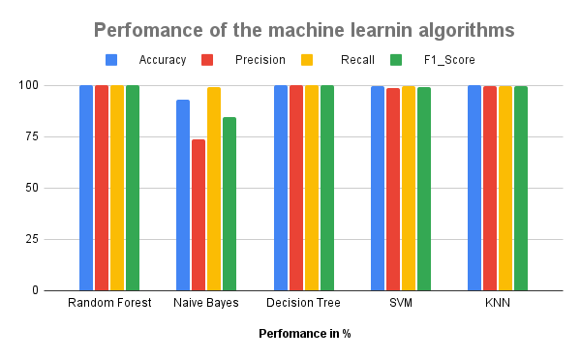
Figure 2.
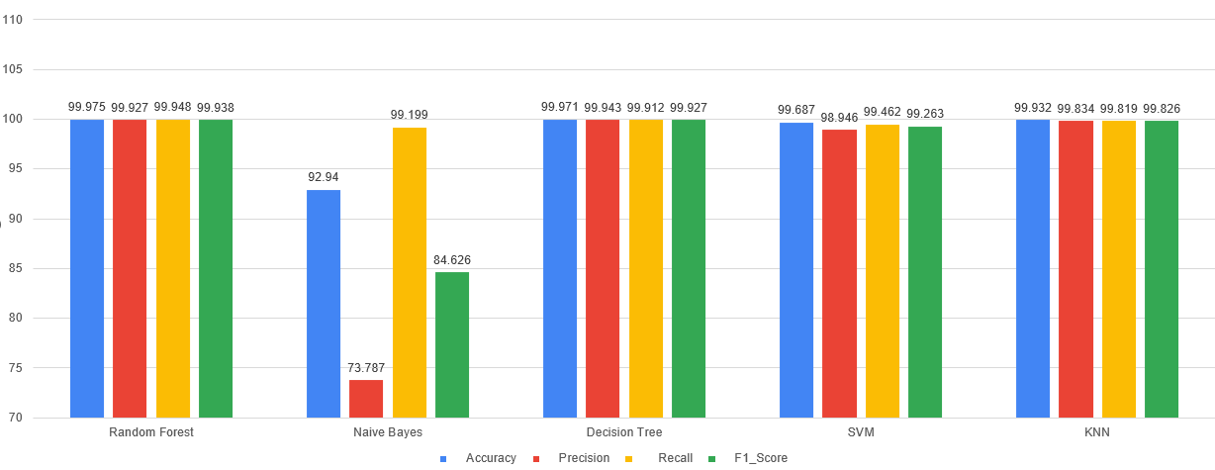

Simulation Results : this should be channgede

- Random Forest Output of 4 metrics
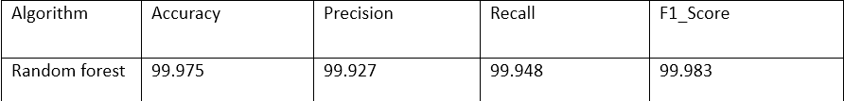

- Naive Bayes Output of 4 metrics
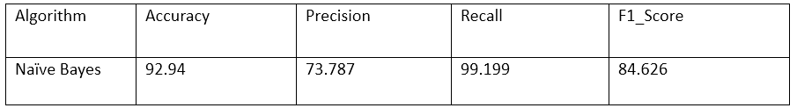
- Decision Tree Output of 4 metrics
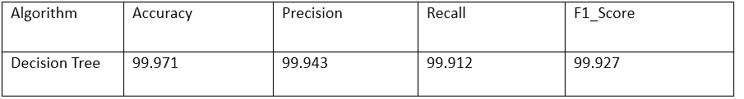
- Support Vector Machine Output of 4 metrics
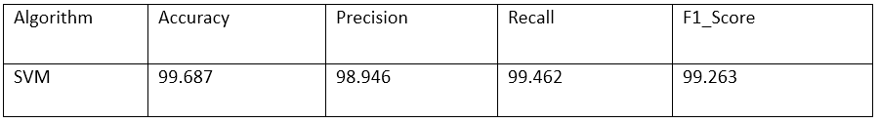
- KNN Output of 4 metrics
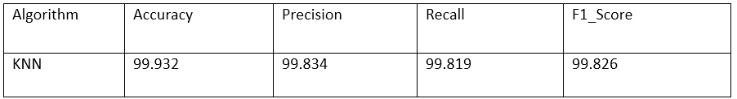

3.Concluding Remarks:

From the simulation results we came to know that Random forest algorithm performed well and Decision Tree and KNN in next places by simulation result.

References
- Saghezchi, F. B., Mantas, G., Violas, M. A., de Oliveira Duarte, A. M., & Rodriguez, J. (2022). Machine learning for DDoS attack detection in industry 4.0 CPPSs. Electronics, 11(4), 602.
- Banitalebi Dehkordi, Afsaneh, MohammadReza Soltanaghaei, and Farsad Zamani Boroujeni. "The DDoS attacks detection through machine learning and statistical methods in SDN." The Journal of Supercomputing 77 (2021): 2383-2415.
- Salih, Azar, et al. "A survey on the role of artificial intelligence, machine learning and deep learning for cybersecurity attack detection." 2021 7th International Engineering Conference “Research & Innovation amid Global Pandemic"(IEC). IEEE, 2021.
- Dataset: https://www.kaggle.com/datasets/galaxyh/kdd-cup-1999-data/data?select=kddcup.data.gz

